**Accessing Assessment Master Training Guide**

To access this guide login into NZQA, then into the Education Sector.

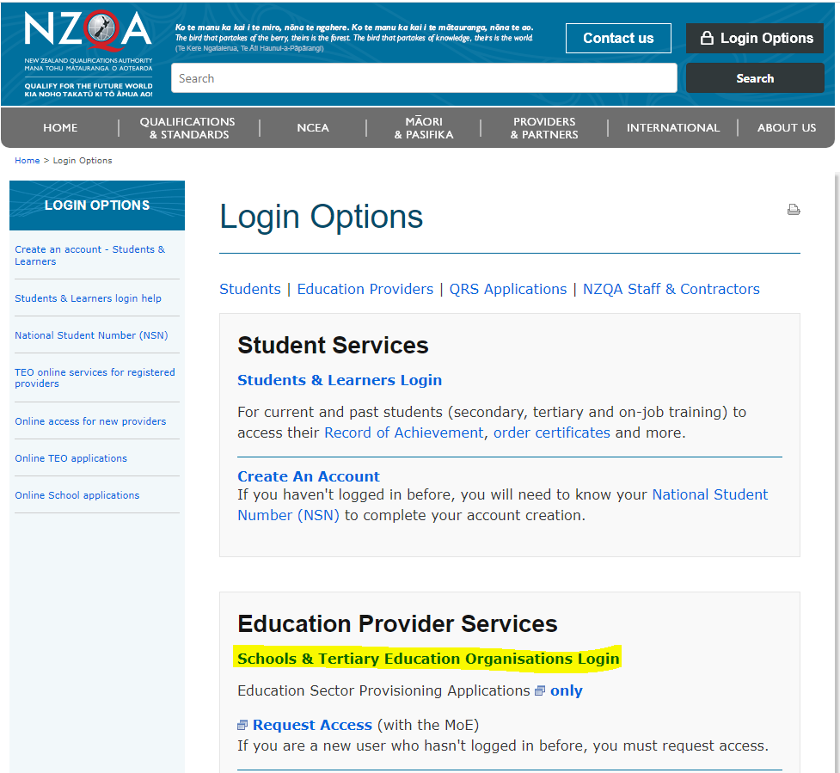

Once there Select Pūtake, if this is not an option, talk with your ESL admin manager and get them to add this to you

Once there select Catalogue, then digital assessments, then Assessment Master

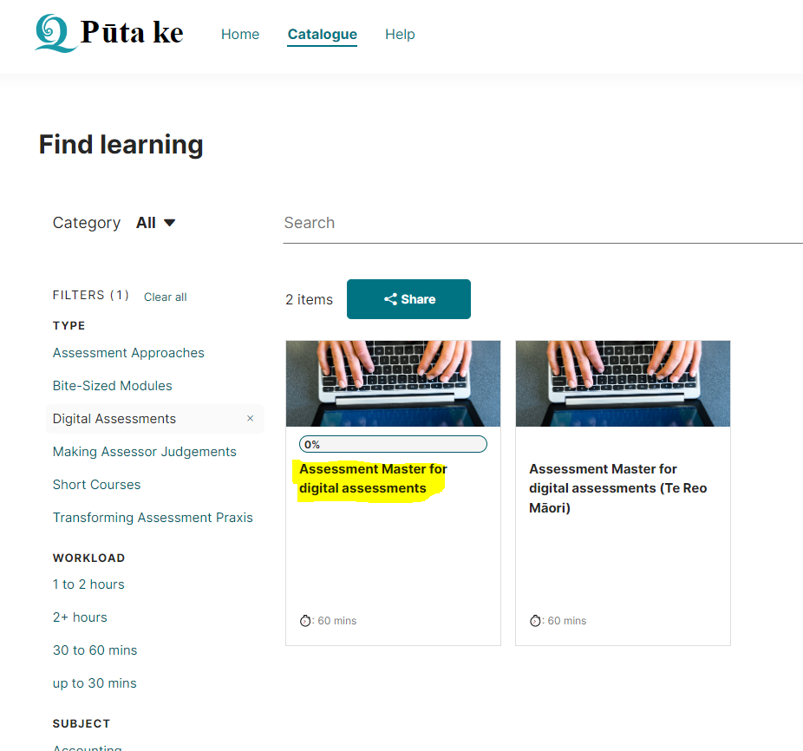

There is another link on the School’s Home page with Assessment Master Guides

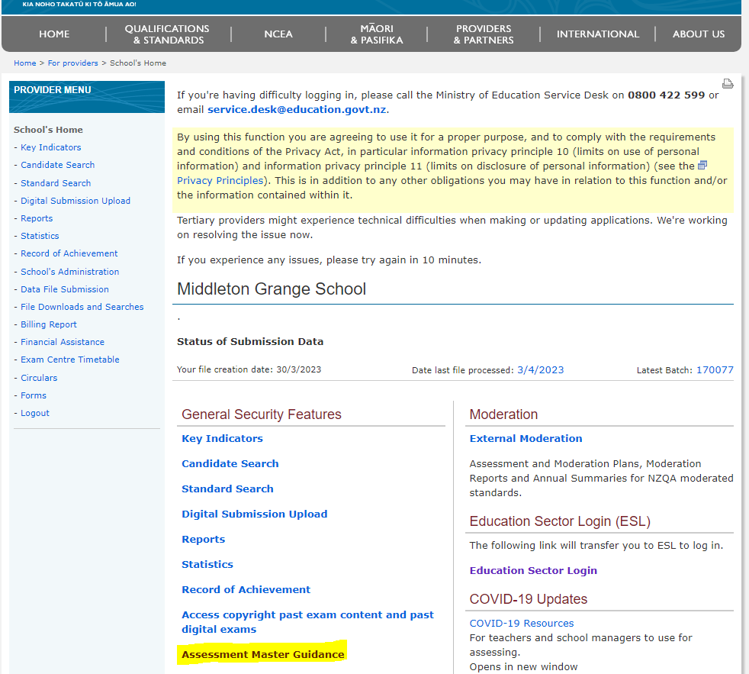

**Accessing information for Digital Assessments**

Go to the NCEA Tab and select NCEA exams and portfolios, then select External exams

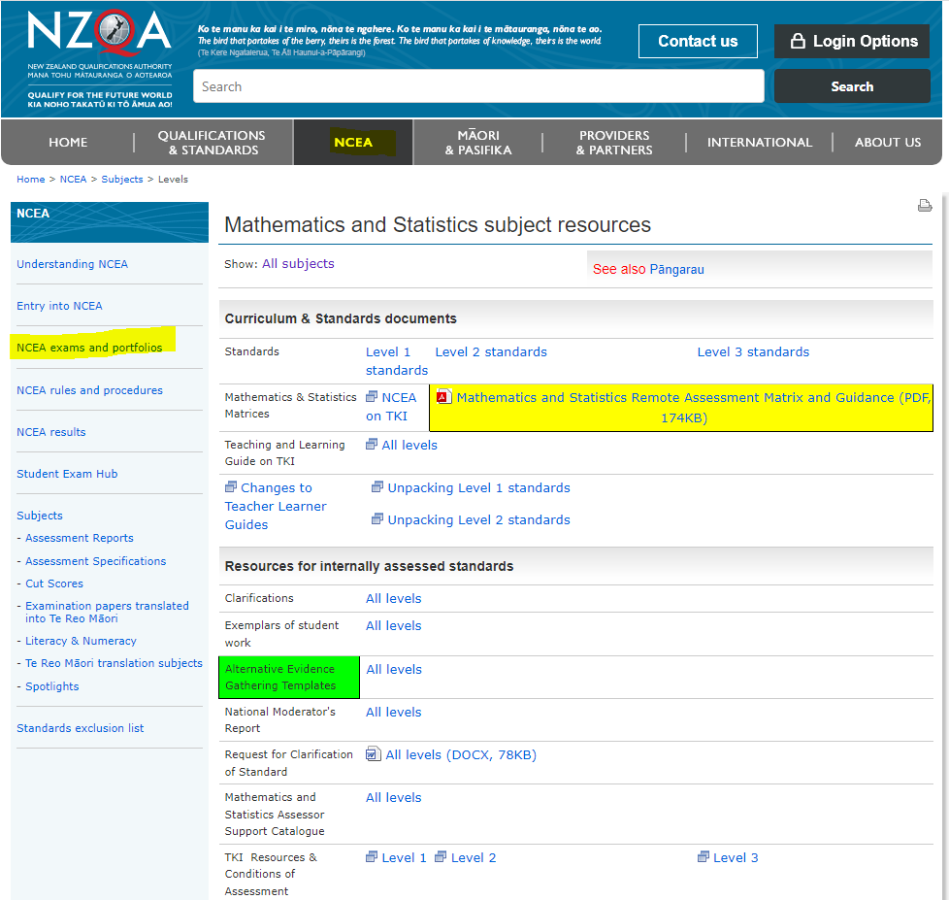

The top two entries give information for digital exams

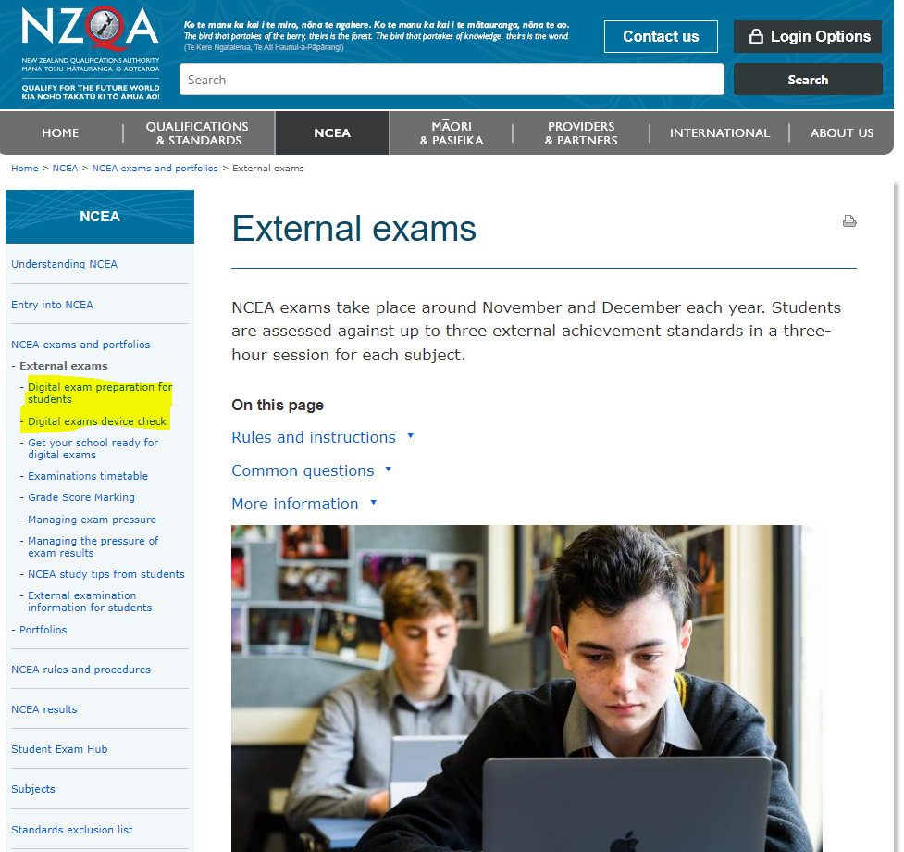

**Accessing previous Digital Assessments**

Go to the NCEA School home page, and access copyright past exam content

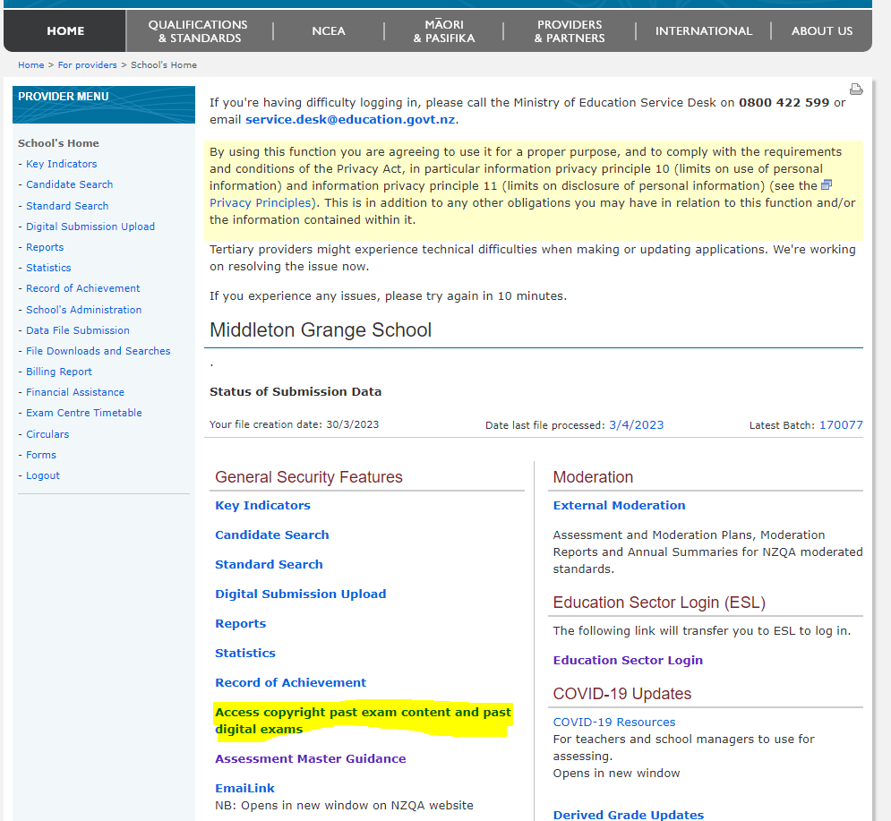 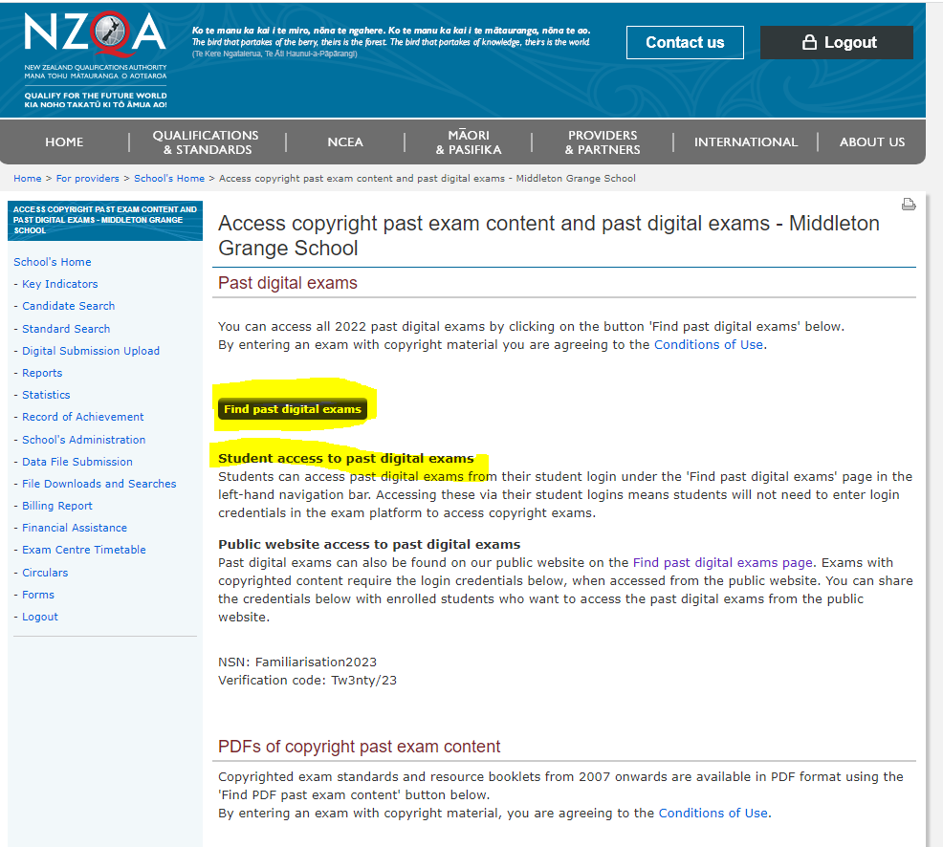

Note that students can access these past pares through their own login in the left hand navigation bar. Note the code is typically 0000.

