# Pilot of literacy and numeracy standards

This year, Ōtūmoetai College (ŌTC) is supporting the Ministry of Education and NZQA to pilot the new foundational literacy and numeracy standards.

Year 10 students (except for those in Supported Learning and Special Needs) will be piloting the following three standards:

* Literacy | Reading - Read written texts to understand ideas and information
* Literacy | Writing - Write texts to communicate ideas and information
* Numeracy - Use mathematics and statistics to meet the numeracy demands of a range of situations

Most Year 10 students are expected to be at the level these standards are set at hence our decision to pilot with our current Year 10s (and a small number of Year 9s). Doing this pilot will reduce the number of standards you will need to do next year to complete your NCEA.

What do you need to know about ŌTC being a pilot school?

* There will be a Common Assessment Activity (CAA) for each standard i.e all students nationally do the same three tests.
* The CAAs will be sat at school, online in a classroom using your own laptop. You will need an NZQA Learner Login [Please follow the instructions on the next page]
* The three assessments will take place on three separate days in Week 9 of Term 2. For example, Reading on Tuesday, Writing on Wednesday and Numeracy on Thursday. Further detailed information will be provided closer to the time.
* Each assessment should take approximately 60 minutes. However, if more time is needed, that is fine but each assessment must be within one sitting and the student must be supervised continuously.
* There is no financial cost to sit these standards.
* For those students who do not pass the standard, there will be a different CAA available in a second opportunity in Week 9 of Term 3.
* If you do not pass the standards during this pilot year, you will have the opportunity to sit the assessment(s) in 2023.
* For students who pass these standards this year, they will count towards their NCEA in 2023 i.e you won’t have to sit them again.
* Further information is available at <https://ncea.education.govt.nz/literacy-and-numeracy/numeracy/learning>

Instructions to create an NZQA Learner Login account

Each student is assigned a unique National Student Number (NSN) by the Ministry of Education when they start school.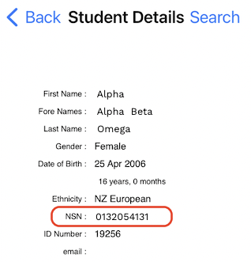

To find your NSN, login to the KAMAR app on your phone and in Student Details your NSN is in the seventh line

OR

login to the KAMAR portal ​​<https://kamar.otc.school.nz/> and select Contact Details then Student Details.

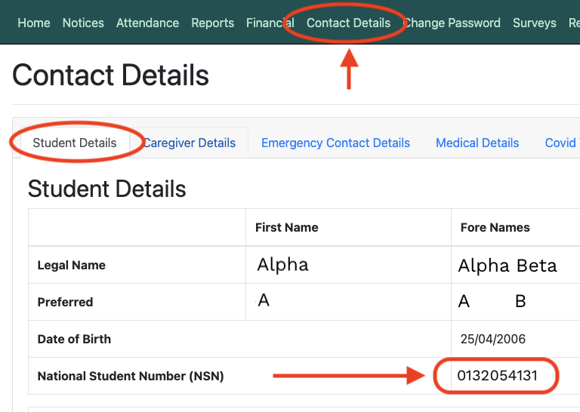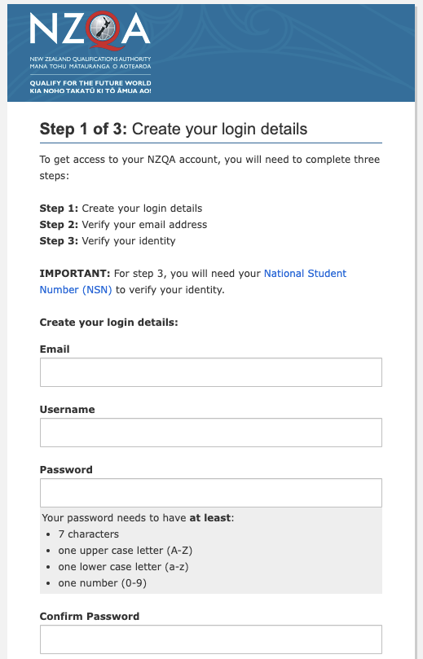

You need your NSN to create your NZQA Learner Login.

Once you have your NSN, you will need to create an NZQA Learner Login account.

1. Go to [www.nzqa.govt.nz/learner-login](http://www.nzqa.govt.nz/learner-login)

2. Click Create account and use your school email address (e.g namea@stu.otc.school.nz) to create your login details by following the three steps.

If you cannot remember your password or have any issues with your account, please phone the NZQA Helpdesk 0800 697 296 for assistance.

You will then use your NZQA Learner Login to access the NZQA website and complete digital exams (like Literacy | Reading, Literacy | Writing and Numeracy). Digital Exam preparation information is available via [this link](https://www.nzqa.govt.nz/ncea/ncea-exams-and-portfolios/external/digital-exams/).

