# Students to Pilot Literacy and Numeracy Standards

This year, Ōtūmoetai College (ŌTC) is supporting the Ministry of Education and NZQA to pilot the new foundational literacy and numeracy standards.

The new standards will help ensure that students have the foundational skills to support them in further studies, work, and life. These standards are currently scheduled to become a mandatory part of NCEA from 2023.

The pilot is part of changes that are happening to strengthen NCEA.

Our Year 10 students and a small number of year 9s (except for those in Supported Learning and Special Needs) will be piloting the following three standards:

* Literacy | Reading - Read written texts to understand ideas and information
* Literacy | Writing - Write texts to communicate ideas and information
* Numeracy - Use mathematics and statistics to meet the numeracy demands of a range of situations

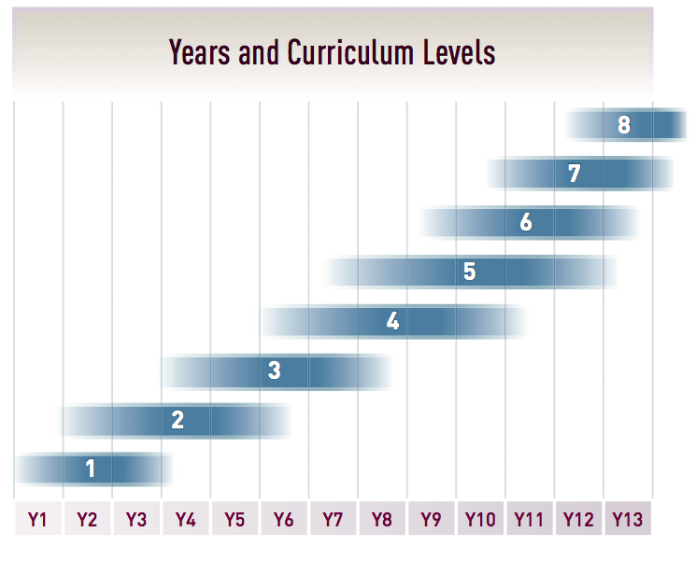

The new standards are designed for learners that have control of Curriculum Level 4 and are ready to work at Level 5. Most Year 10 students are expected to be in that category hence our decision to pilot with our current Year 10s (and a small number of Year 9s). Doing this pilot will reduce the number of standards Year 10 students will need to do next year to complete their NCEA.

What do you need to know about ŌTC being a pilot school?

* There will be a Common Assessment Activity (CAA) for each standard i.e all students nationally do the same three tests.
* They will be sat at school, online in a classroom using their own device. Students will be emailed instructions on how to create an online NZQA Learner Login so that they can access the assessments.
* The three assessments will take place on three separate days in Week 9 of Term 2. For example, Reading on Tuesday, Writing on Wednesday and Numeracy on Thursday. Further detailed information will be provided closer to the time.
* Each assessment should take approximately 60 minutes. However, if more time is needed, that is fine but each assessment must be within one sitting and the student must be supervised continuously.
* There is no financial cost to sit these standards.
* For those students who do not pass the standard(s), there will be a different CAA available in a second opportunity in Week 9 of Term 3.
* If your student does not pass the standards during this pilot year, they will have the opportunity to sit the assessment(s) in 2023.
* For students who pass these standards this year, they will count towards their NCEA in 2023 i.e they won’t have to sit them again.

What can you do to support your student?

* Encourage your student to read and write at home or in their day-to-day activities.

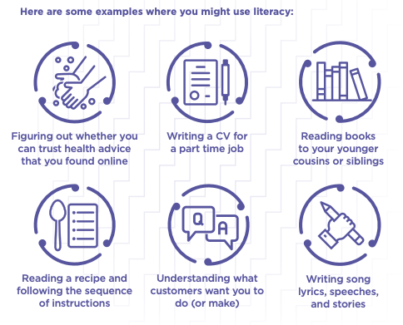

* Recognise when mathematics and statistics is used. For example calculating prices; interpreting tables, maps, bank statements, timetables, graphs, and diagrams; using a degree of precision appropriate to the situation (estimating); and explaining the reasonableness of answers.

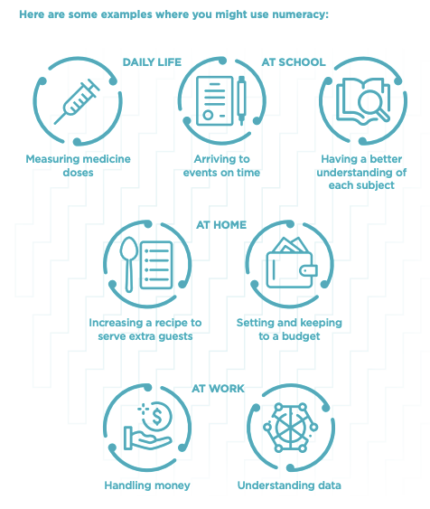

* Encourage your student to ask for help from their subject teachers when they need it.
* Familiarise yourself with this ‘NCEA Literacy and Numeracy for Students and Whānau’ information from the Ministry available at <https://ncea.education.govt.nz/ncea-literacy-and-numeracy-students-and-whanau>
* Further information is available at <https://ncea.education.govt.nz/literacy-and-numeracy/numeracy/learning>

Education academic Michael Johnston is a senior fellow at the New Zealand Initiative and worked on the study that first identified teens' poor literacy and numeracy. He has said that the standards look well designed and that “the assessments look to be assessing the kinds of things that people would need to be able to do in everyday life."

Thank you for supporting your student through this pilot.